|  |  |  |  |
| --- | --- | --- | --- |
| **Campus** | **NPI** | **C:\Users\dell\AppData\Local\Microsoft\Windows\INetCache\Content.MSO\73217333.tmpC:\Users\dell\AppData\Local\Microsoft\Windows\INetCache\Content.MSO\CEBCC6B9.tmp** | Please Tick (✓) for  **Re-do Assignment** |
| **APU Foundation & Degree**  **Programmes** | |  |

**Coursework Submission and Feedback Form**

|  |  |  |  |  |  |
| --- | --- | --- | --- | --- | --- |
| **Name** | **Jiten Chapagain** | | | | **Name of Group Members (If Applicable)** |
| **Student No.** | **NPI000150** | | **Intake:** | **NPI1F2202IT** | Ankit Acharya(NPI000140) |
| **Module Code & Title** | **CT043-3-1(Introduction to Networking)** | | | | Pukar Nepali(NPI00165) |
| **Assignment Title** | **Seagate.c** | | | | Satindra Bahadur Khadka(NPI000178) |
| **Name of Lecturer** | **Yubraj Sharma** | | | |  |
| **Date Due** | **2022/06/31** | **Student E-Mail: jitenchapagain2202it@infomaxcollege.edu.np** | | |  |

*I have read and understood the regulations on Plagiarism and Academic Dishonesty and declare that the work submitted does not breach those regulations.* **Signed: ________________________________**

**You must hand in to the designated APU Administrator – ensure that you receive your receipt**.

|  |  |  |  |  |  |  |  |
| --- | --- | --- | --- | --- | --- | --- | --- |
| **Received By** |  | **Signature** |  | **Date** |  | **Time** |  |

|  |  |  |  |  |  |  |  |  |  |  |  |
| --- | --- | --- | --- | --- | --- | --- | --- | --- | --- | --- | --- |
| **Criteria** | | | **Weighting** | | **Fail** | **Marginal**  **Fail** | **Pass** | | **Credit** | | **Distinction** |
|  | | |  | |  |  |  | |  | |  |
| **Additional Comments:** (These may be listed below or attached) | | | | | | | | | | | |
|  | | | | | | | | | | | |
| **Provisional Assessment Result:                                                                                          Grade            Date                Lecturer’s Initial**  **C:\Users\dell\AppData\Local\Microsoft\Windows\INetCache\Content.MSO\699B122F.tmpC:\Users\dell\AppData\Local\Microsoft\Windows\INetCache\Content.MSO\A5494B15.tmpC:\Users\dell\AppData\Local\Microsoft\Windows\INetCache\Content.MSO\C40F82EB.tmp**  Taking account of above factors, the overall provisional assessment of your work is: | | | | | | | | | | | |
|  | | | | | | | | | | | |
| **Distinction** | | **Credit** | | | | **Pass** | | | | | |
| **A+: 80-100%** | **A: 75-79%** | **B+: 70-74%** | | **B: 65-69%** | | **C+: 60-64%** | | **C: 55-59%** | | **C-: 50-54%** | |
| **Marginal Fail** | | **Fail** | | | | | | | | | |
| **D: 40-49%** | | **F+: 30-39%** | | | | **F: 20-29%** | | | **F-: 0-19%** | | |

*The comments and assessment result are subject to both internal and external moderation at the appropriate Examination Board.*

*Consequently, they may not reflect your final grade. You may not appeal against this result on ground of Academic Judgement.*





Table of Contents

OBJECTIVE 6

ASSUMPTION 7

1.0 FLOOR PLAN 8

1.1 FIRST FLOOR PENANG BUILDING (Jiten Chapagain-NPI000150 8

1.2 SECOND FLOOR PENANG BUILDING (Satindra Bahadur Khadka-NPI000178) 9

1.3 CYBERJAYA FLOOR FIRST (Pukar Nepali-NPI000165 10

1.4 CYBERJAYA SECOND FIRST ( Ankit Acharya-NPI000140) 11

2.0 NETWORK DEVICE 12

2.0 Router 12

2.1 Switch 13

2.2 Wi-Fi Access Point 14

2.3 VOIP (Voice Over Internet Protocol) 15

2.4 Personal Computer (Desktop) 16

2.5 Laptop 17

2.6 Closed Circuit Television. (CCTV) 18

2.7 CAT6 cable 19

2.8 Printer 20

**3.0** **Overall configuration**  21

3.1 Penang first floor (NPI000150-Jiten Chapagain) 23

3.2 Penang second floor (NPI000178-Satindra Bahadur Khadka) 24

3.3 Configuration involve in this building is done by (Jiten Chapagain-NPI000150 & Satindra Bahadur Khadka-NPI000178) 25

3.4 Cyberjaya first floor (NPI000165-Pukar Nepali) 31

3.5 Cyberjaya second floor (NPI000140-Ankit Acharya) 32

3.6 Configuration involve in this building is done by (Pukar Nepali-NPI000165 & Ankit Acharya-NPI000140) 33

4.0 SERIAL LINK BETWEEN PENANG ROUTER AND CYBERJAYA ROUTER 39

4.1 Penang router serial link configuration 39

4.2 Cyberjaya router serial link configuration 40

4.3 Penang building Dial peer configuration 42

4.4 Cyberjaya building Dial peer configuration 42

5.0 TOPOLOGY 44

6.0 IP-Addressing 45

7.0 IP-ADDRESSING ROUTERS 48

8.0 Conclusion 51

9.0 Reference 52

## OBJECTIVE

The main purpose of this assignment is to make the network plan for the hardware company known by Seagate.co. The company is in Malaysia and they are planning to create the new network designed for their two building. The names of the two buildings for which we are making the network diagram are Penang and Cyberjaya. Our main purpose is to make the network designed for those two buildings. The pictorial picture i.e., network diagram is done using cisco packet tracer. After that the documentation was done. As we know there are two buildings, we do sub netting and give the network. To make the design we make the diagram using star topology and tree topology. We have used many devices which are essential in the company like computers, laptop, Wi-Fi, router, CCTV, VoIP phone, printer, server etc.

## ASSUMPTION

In this network diagram we have made many of the assumptions which are essential for the company to run in a smooth way without any hindrance. In this network diagram there are access points with password which help to secure data for being incorrupt. Furthermore, we use Ethernet cable to share network help reduce chance of data incorruption. In the switch box we open all the ports and make them accessible so that we can easily connect the other device and switches as per our requirement and need. In telephone service the max number of phones we can use is only 10 because another person cannot connect and listen to the communication.

## FLOOR PLAN

* 1. 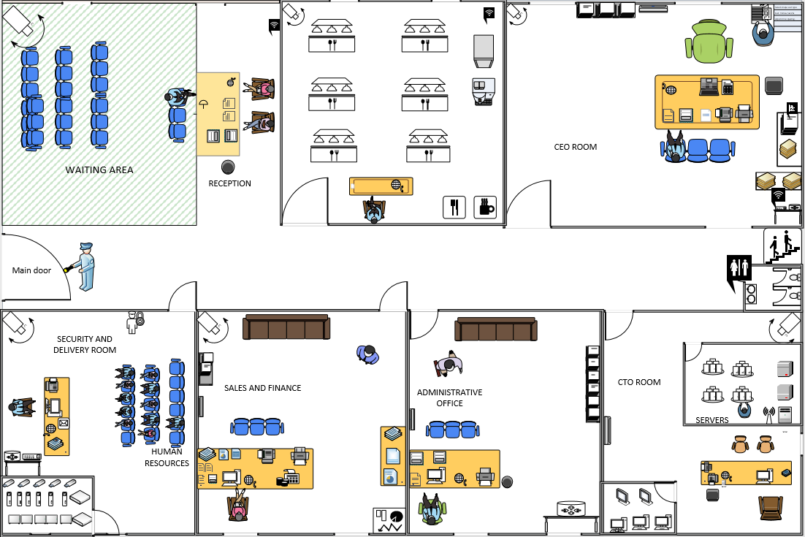FIRST FLOOR PENANG BUILDING (Jiten Chapagain-NPI000150**)**

All the above-mentioned floors are designed using Microsoft Visio. This is floor number one of the building Penang. In the entrance of the building, we have all basic departments which should be in office which includes waiting area for our candidate on the left-hand side of the floor. Next to it we have Reception to check the candidate and to inform them of the situation. Next to the reception we have a cafeteria where both office staff as well as candidates are also allowed. On the right side, to ensure the security as well as Delivery part of the office we have security and delivery room, Sales and finance room to ensure the finance depart of the office as well as sales of company. The administration room is next to the Sales and finance and CTO room next to it including the servers in it, having strong internet connection. We can see CEO room right in front of the CTO room next to toilets for both male and female. All rooms consist of CCTV having high quality video recording to inspect every single act of the staff as well as the candidate. VoIP Phones are installed in every single room besides the waiting room and cafeteria. There are two stores rooms in Security and CTO room where all the spare and backup computer parts are stored. The stairs are at the end of the floor next to the toilet, which allows us to move to the next floor of the same building.

### SECOND FLOOR PENANG BUILDING (Satindra Bahadur Khadka-NPI000178)

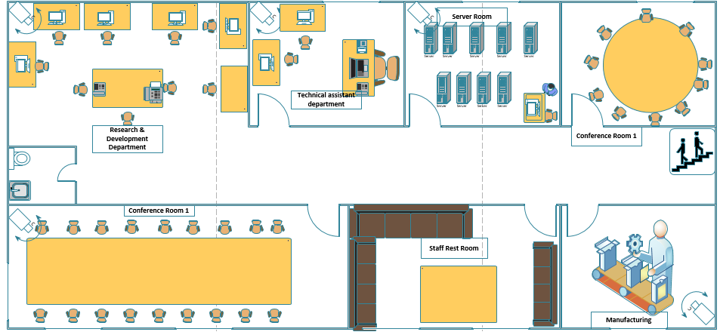

All the above-mentioned floors are designed using Microsoft Visio. This is floor number second of building Penang.  In the entrance of the floor, we have Conference hall1 in the right-hand side consists meeting table and the next conference hall2 is at the next corner of the floor with the capacity of holding more than 20 staff. There is a server room next to the conference hall1. Next to the server room there is technical assistant department room consisting only three staff capacity and next to it there is Research and development department where all the necessary information for the projects is collected through many resources. There is a toilet in the middle of the research department and conference hall2. There is also a rest room for the staff where staff can take a rest after or before work. It is on the left side of the floor. Next to the entrance of the floor there is a manufacturing department on the right side where all the sample products are handmade. All the rooms are under the surveillance of the high-quality video recording CCTV.

* 1. CYBERJAYA FLOOR FIRST (Pukar Nepali-NPI000165**)**

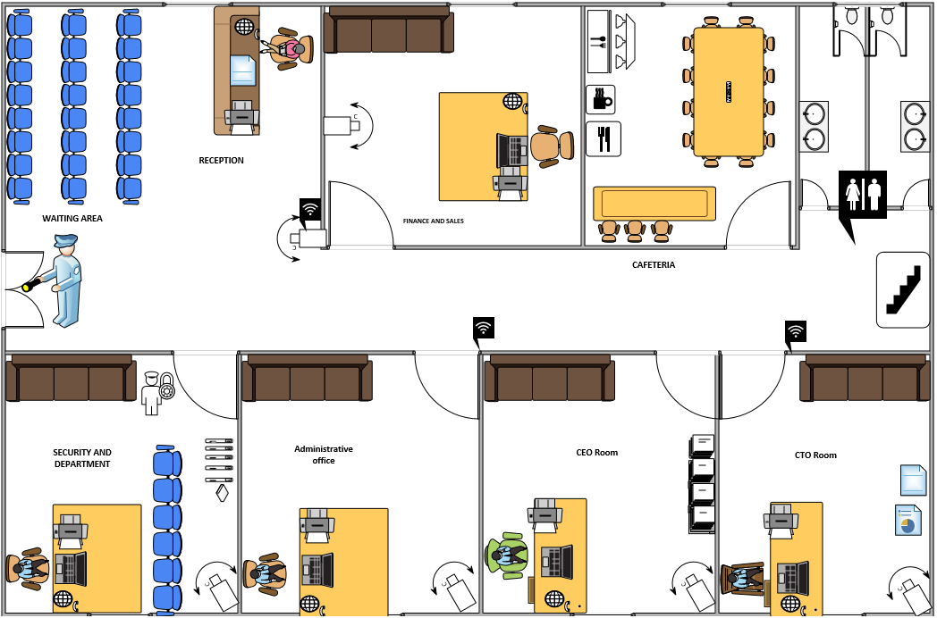

This is floor number one of building Cyberjaya. In the entrance of the building, we have all basic departments which should be in office which includes waiting area for our candidate and reception area on the left-hand side of the floor including a High-Quality CCTV for the better security in the entrance. Next to it we have Reception to check the candidate and to inform them of the situation. Next to the reception we have the finance and sales department under high surveillance. Next to it there is a cafeteria where only staff are allowed and at the end there is a toilet and stairs to climb up to the next floor. On the right side of the floor there is the security and delivery department with the high security door where only a few staff with access are allowed. Next to it there is the Administration Office. And after that there is the CEO room which is at the middle of CTO room and Administration Office. There is exist of VoIP Phone in all the rooms expect the cafeteria. High Quality CCTVs are all over the floor which makes the floor more secure and all the acts of staff and candidate can be tracked easily.

### CYBERJAYA SECOND FIRST ( Ankit Acharya-NPI000140)

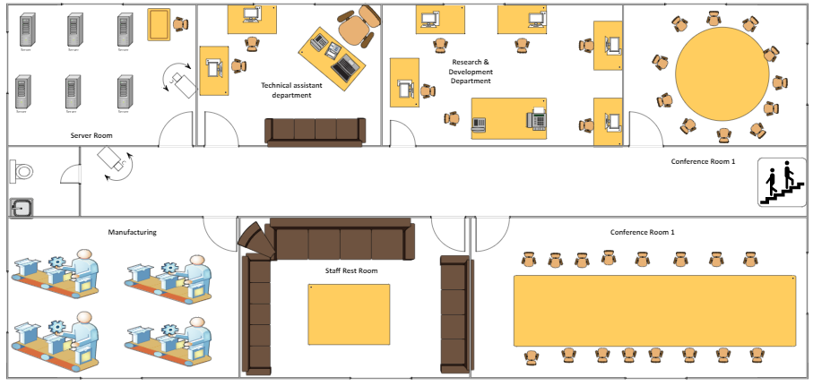

This floor is the busiest in the whole structure. This level is generally used for meetings. It's well-equipped, with enough room for a large number of staff and clients to meet. The servers are kept in this Server Room by our firm. It's in the building's corner because the servers tend to overheat, so we keep them in the corner room where the sun shines less throughout the day. The technical assistant will use this space to administer and survey the network of this building. The Manufacturing room is on the left side of the corridor. This is the location where the developers in the research and development department bring their thoughts to life. The R&D department room has five workstations, each with a high-end desktop computer and an additional sixth desk and chair with a VOIP phone and fax machine. Each developer works in this space to help our organization reach new heights by studying fresh concepts. The staff restroom is located between the conference and manufacturing rooms on the left side of the corridor. Conference Room 1 is the space where large-scale meetings between company founders and clients take place. When you climb up the stairs on the left side of the corridor, this is the first chamber you encounter. Unlike Conference Room 1, Conference Room 2 is a much smaller room which is used to hold meetings among the staff of the company. It is the first room on the right side of the corridor as you climb up the stairs.

## NETWORK DEVICE

### Router

The networking device which send data packet from one computer to other computer network is known as Router. It is a crucial equipment in networking communication because it connects the local network, such as computers and other devices, to the internet. They are frequently characterized by the network over which they operate. A router in a single organization's local area network (LAN) is termed an inferior router, while a router that links a LAN to the internet or a wide area network (WAN) is called a gateway router. The routers are linked to a device such as a switch through a network connection, and the switch is then connected to another network cable to connect to other devices. Static routing will be used to configure the routers in this assignment.

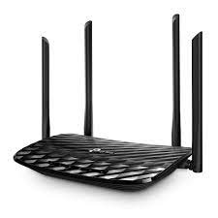

Fig: TP-Link archer c6 AC1200 wireless MU-MIMO gigabit router. (Ref. TP link)

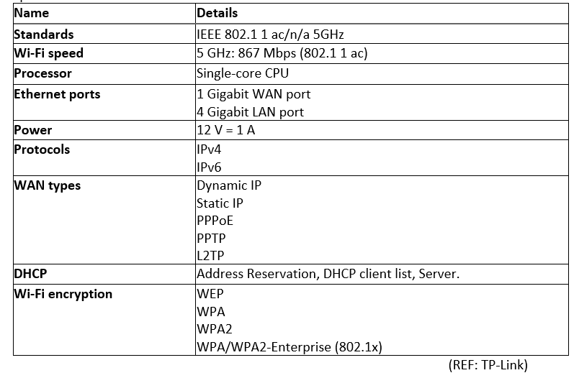Specifications.

### Switch

Switches are networking devices that operate at the OSI model's data connection layer. They link several devices in a network and send, receive, and forward data packets over the network using packet switching. They facilitate network communication by linking all devices in a company's network, such as PCs, CCTV cameras, printers, fax machines, and servers. Without switches to link the devices, it is impossible to build a corporate network.

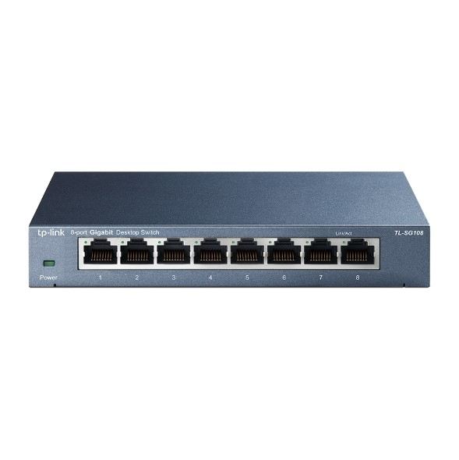

Fig: TP-Link-SG108 V5 (REF TP- Link)

Specifications.

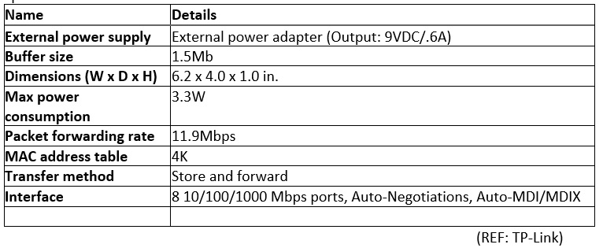

### Wi-Fi Access Point

A Wi-Fi access point is a device that generates a wireless local area network, or WLAN, in a building or workplace. An access point projects a Wi-Fi signal to a specific region after being linked to a wired router, switch, or hub through an Ethernet connection.

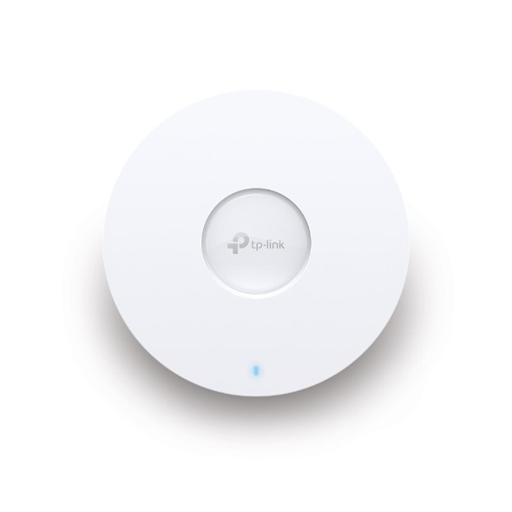

FIG: EAP660 HD AX3600 wireless dual band multi-gigabit ceiling mount access point.

Specifications.

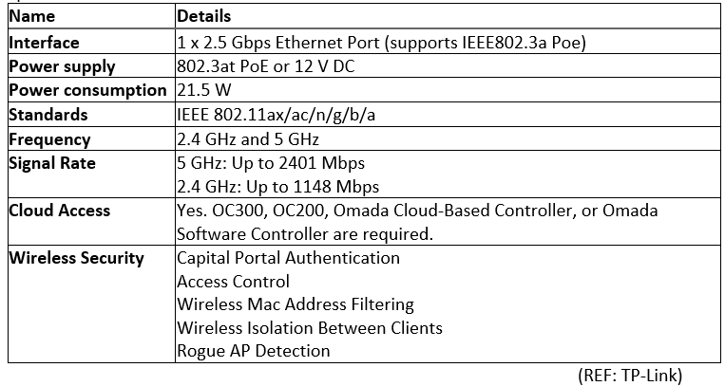

### VOIP (Voice Over Internet Protocol)

The technology which help you to make voice call through the internet rather than other traditional phone line is known as VoIP. VOIP is a technology that is beneficial to both consumers and companies since it often contains additional capabilities not seen on traditional phone systems.

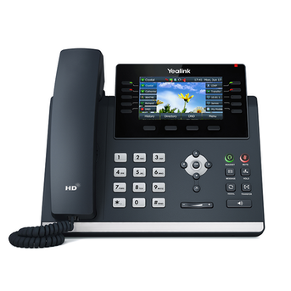

FIG: Yealink T46U IP Phone (REF: Nextiva)

Specifications.

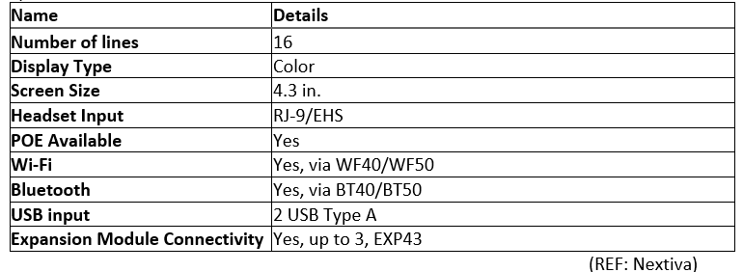

### Personal Computer (Desktop)

Any tiny, reasonably inexpensive computer meant for a single user can be used to perform daily office tasks. The price of these computers may vary from cheap to very expensive. The price is determined by the hardware in the computer such as, processor and the number of cores present in it, RAM, Hard drive or Solid-State Drive etc.

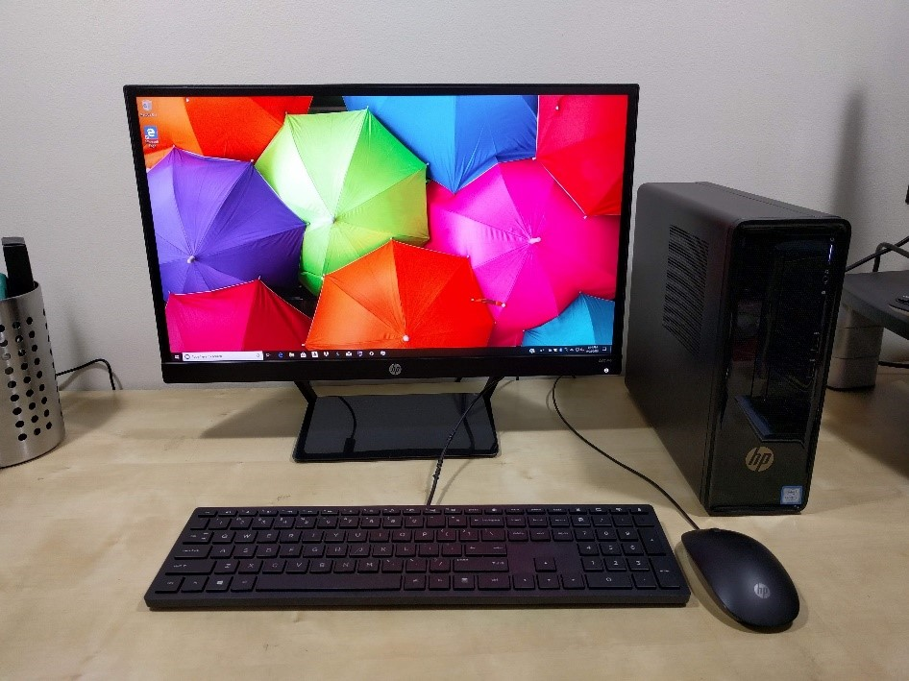

FIG: HP Slim line full desktop environment (REF: Mostly about computers)

Specifications.

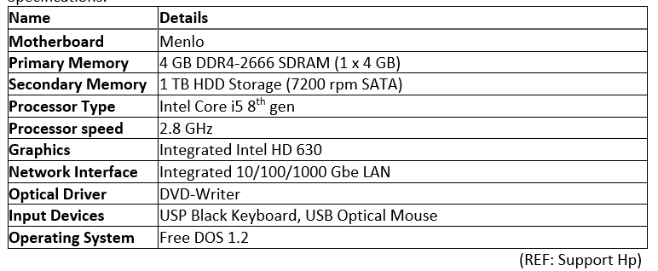

### C:\Users\dell\AppData\Local\Microsoft\Windows\INetCache\Content.MSO\28C741B4.tmpLaptop

A laptop is a computer that is compact and portable. It has a tiny LED screen attached to a keyboard and is relatively light, allowing it to be moved to many locations. Even though it is smaller than a standard computer and has a smaller power source, it is capable of performing as well as a desktop computer. Laptops nowadays include detachable screens and touch displays, allowing them to be used as a tablet.

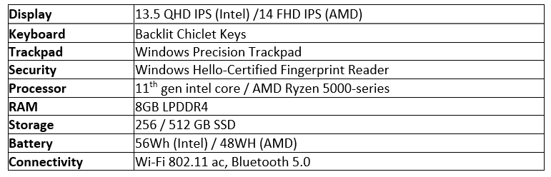

### Closed Circuit Television. (CCTV)

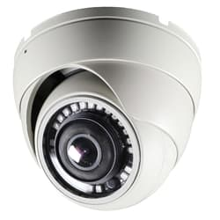

Fig I: HD-D180 180 Degree HD Dome Camera. (REF: cctvcamerapros)

A CCTV camera is essential to ensure the security of any organization. It prevents any kind of theft or misconduct in the office environment. And in order to make our working environment safe we have decided to install the HD-D180 CCTV camera.

Specifications.

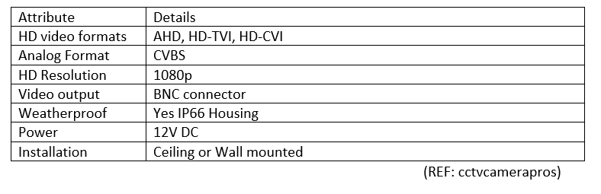

### CAT6 cable

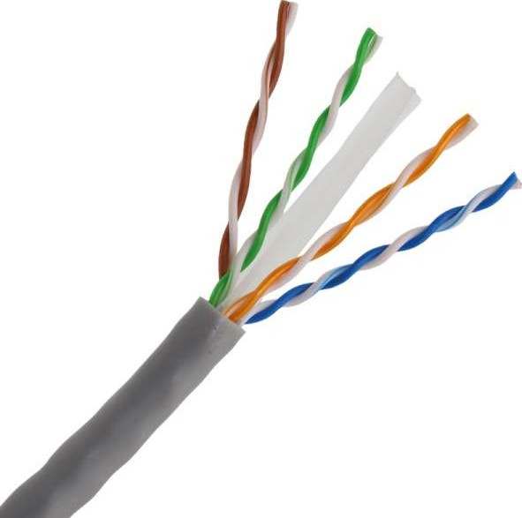

Fig II: AIR-MAX CAT6 UTP 23AWG PVC cable. (REF: Air Pro)

One Gbps or 1000 Mbps of data transfer rate (DTR) or greater computing networks often employ a Cat 6 connection. It has four copper wire pairs that are all used for data transmission. It also lessens "Crosstalk," a signal transmission that interferes with your communications channels.

Specifications.

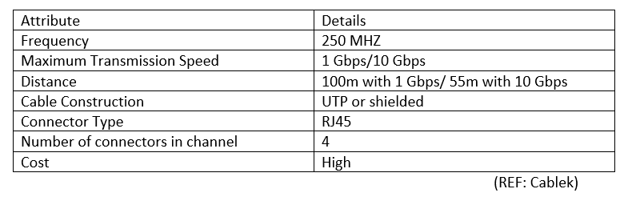

* 1. Printer**.**

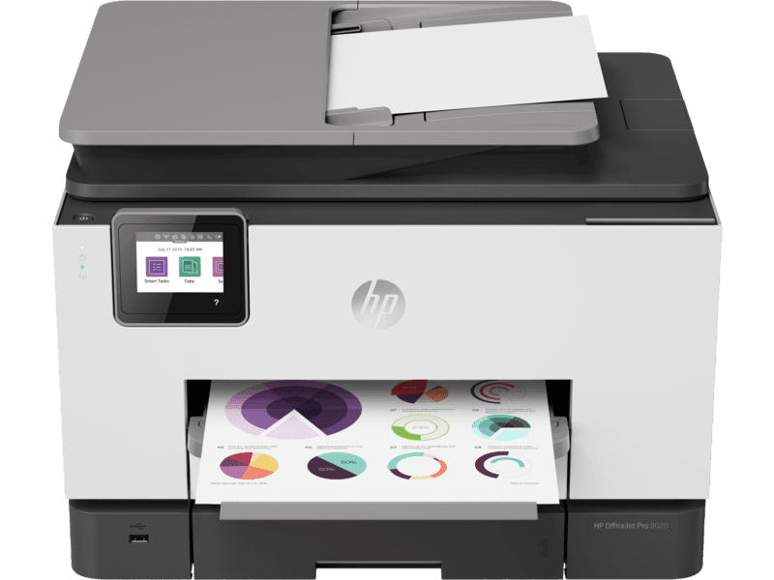

Fig III: HP Office Jet Pro 9020 All-In-Printer. (REF: HP)

In every working environment printer is the most essential component. And since it is very busy the printer must be reliable and can withstand a lot of printing without any complications. The printer that is best suited for our office HP Office Jet Pro 9020.

Specification.

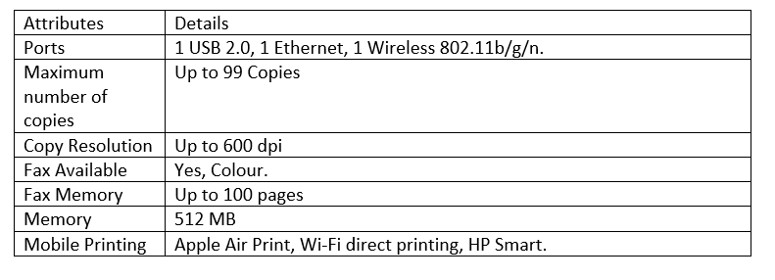

# Overall configuration

Fig :- Network diagram

Penang Router

|  |  |  |
| --- | --- | --- |
| Router Name | IP  S0/0/0 | Subnet mark |
| Penang  (Host name : Router) | 192.168.6.129 | 255.255.255.252 |

Cyberjaya Router

|  |  |  |
| --- | --- | --- |
| Router Name | IP  S0/0/0 | Subnet mark |
| Cyberjaya  (Host name : Router) | 192.168.6.130 | 255.255.255.252 |

The above figure displays the pictorial representation of the network system that is used in computer telecommunication. It helps to manage the network in different fields. Network system diagram helps to distribute the Ip address throughout the system. The above network diagram is design in cisco packet as per the question requirement. In the above figure there are two buildings with two floors in each building. The color of the different floors and buildings is different because to distinguished them differently. Furthermore, the rooms on the floor are also separated by the rectangular box which helps to identify the room clearly.

### Penang first floor (NPI000150-Jiten Chapagain)

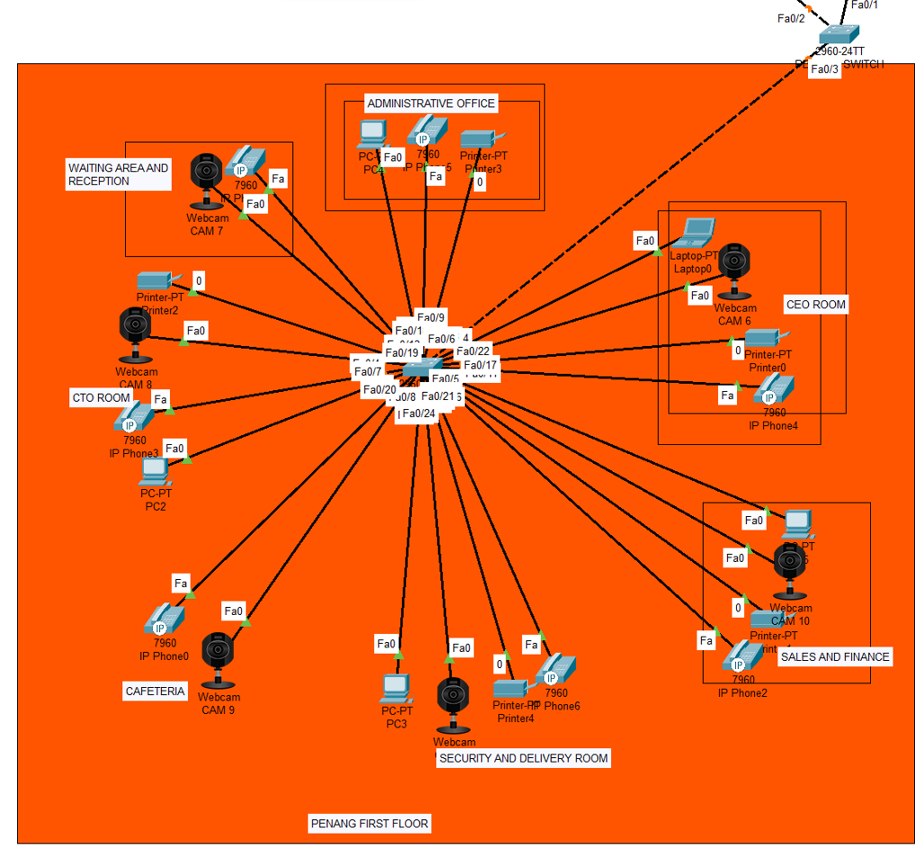

The figure above is designed in cisco packet tracer. This is the diagram representing the first floor of Penang building. There are seven rooms per the question requirement. There are five computers, five printers, six CCTV cameras and seven VoIP phones in two floor of Penang building. Each and every room is connected with the network with the help of some device. The host device from the first floor is connected to the switch using Ethernet cable with the help of copper. Furthermore, copper cross-over cable is used to connect switches. Star topology is used to design networks.

### Penang second floor (NPI000178-Satindra Bahadur Khadka)

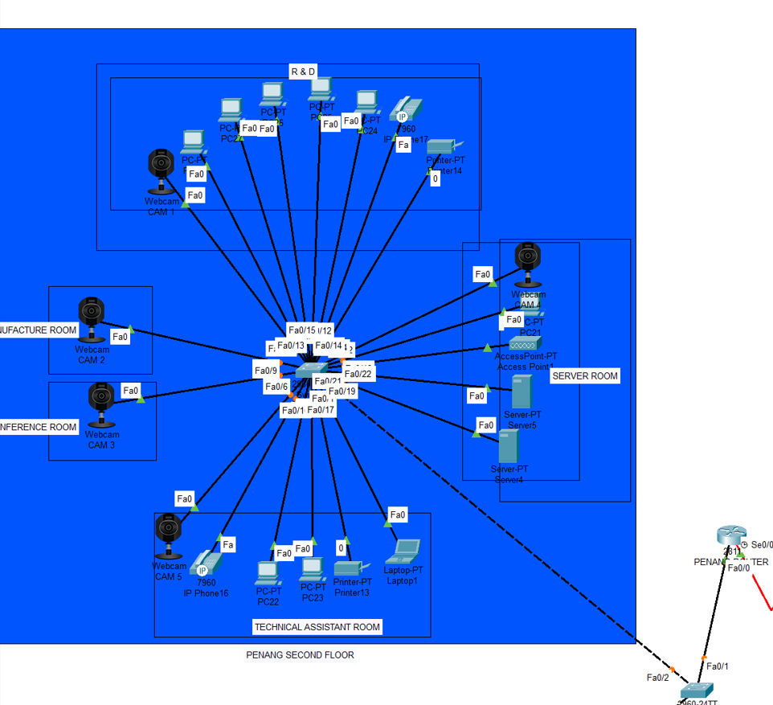

This is the networking figure of the Penang second floor where we can see that there are two server, one access point, nine computer, six CCTV camera, two VoIP and two printer. These device are also connected with the switch of that floor with the help of Ethernet cable and that switch also connected with the building switch with the help of cross over wire and then with the network. This floor is also design in star topology.

### Configuration involve in this building is done by (Jiten Chapagain-NPI000150 & Satindra Bahadur Khadka-NPI000178)

#### Configuration of switch of Penang building

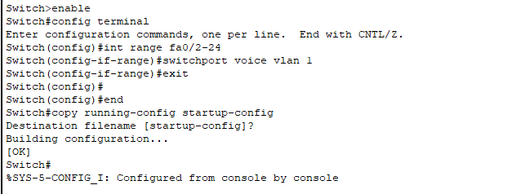

#### Router configuration of Penang building

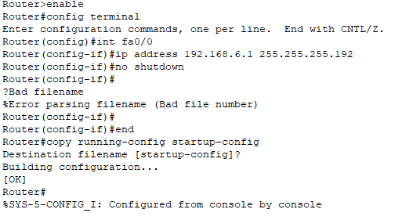

#### Configure DHCP pool to router of Penang building

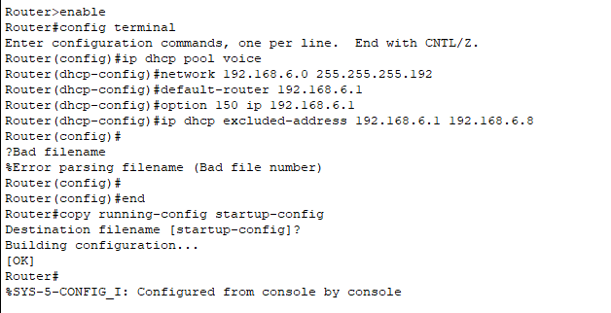

We configure the router of Penang; the PC of that building should connect with the help **DHCP.**

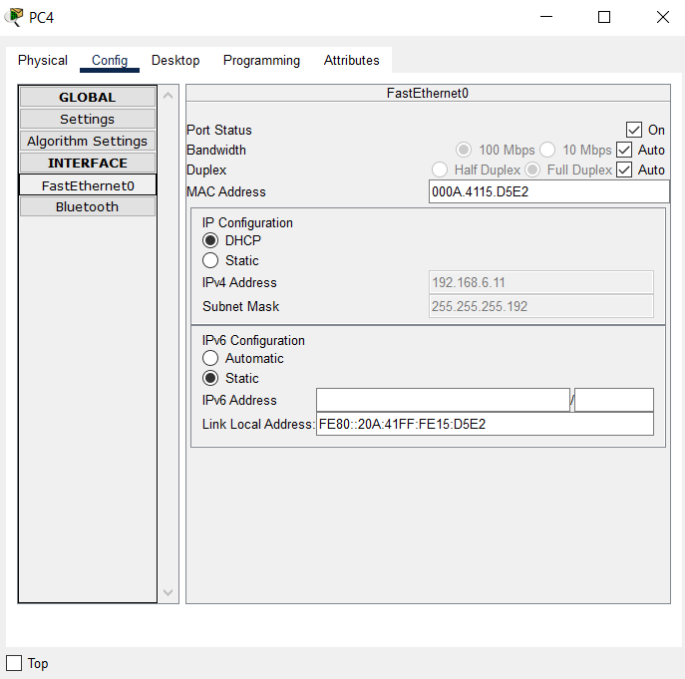

#### Telephony service configuration of Penang building

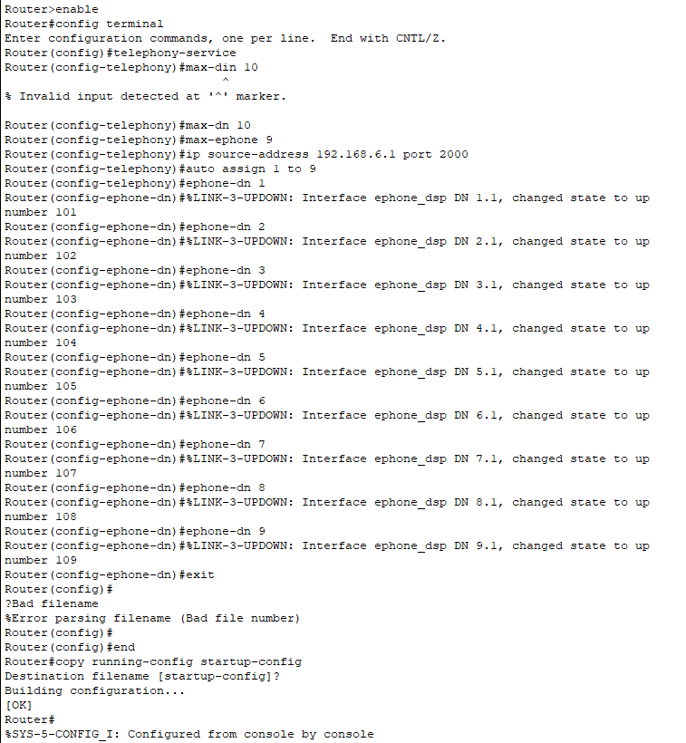

So, the VoIP phone is configuration with the router and they are connected with ip phone adapter.

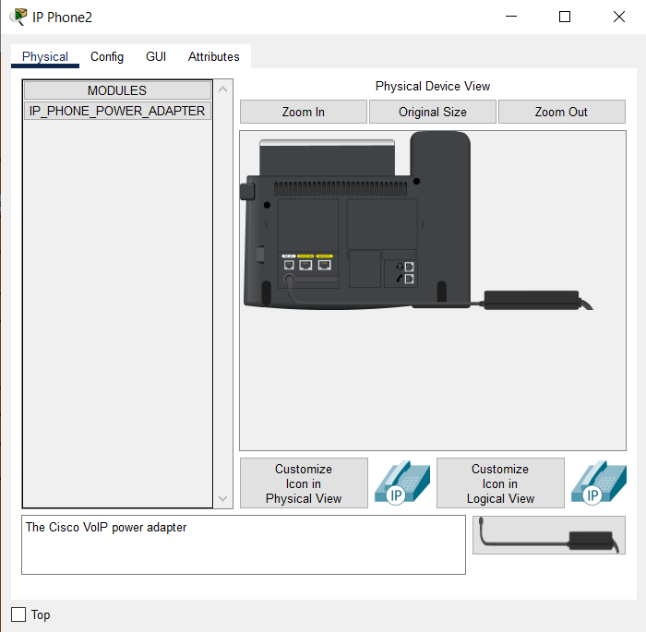

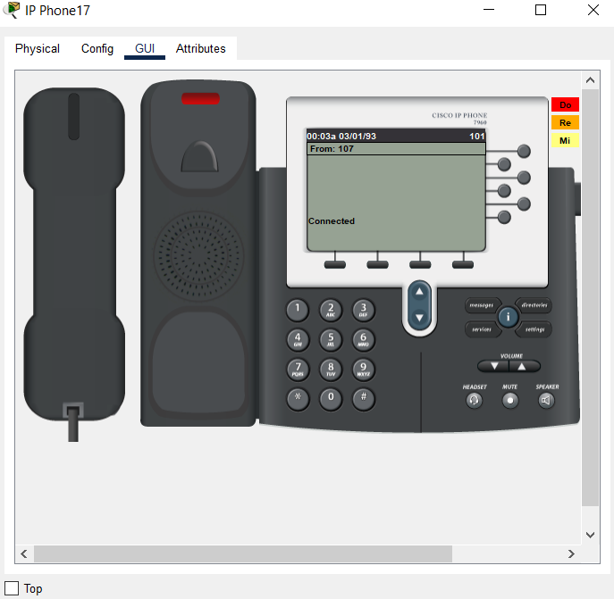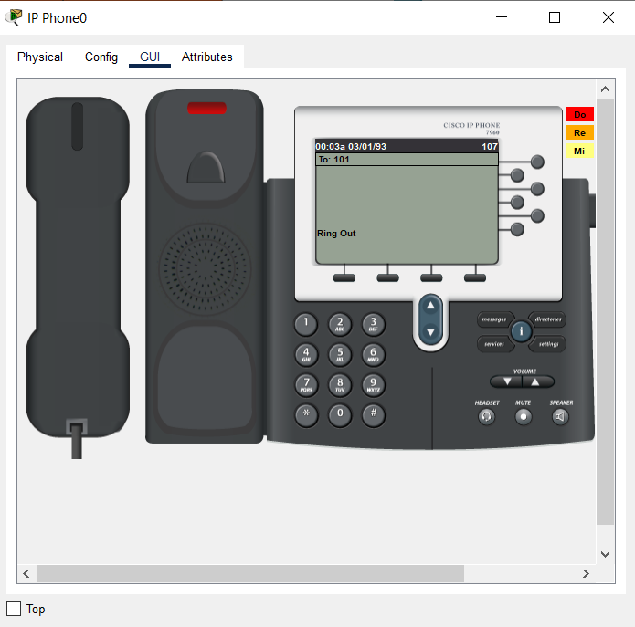We have given number an Ip address to the VoIP phone of building Penang floor first as well as second now they are ready to use.

As from the above diagram you can see that the VoIP pone are successfully connected and they can ring from one floor to another floor.

Furthermore, the printer, server and camera from the Penang building has given ip address statically.

**CCTV**

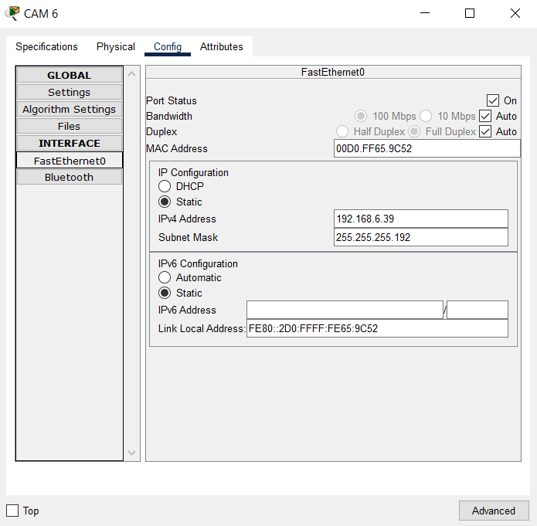

**Printer**

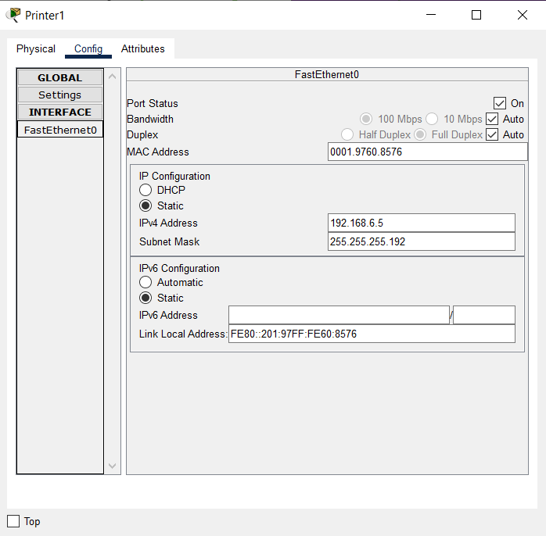

**Server**

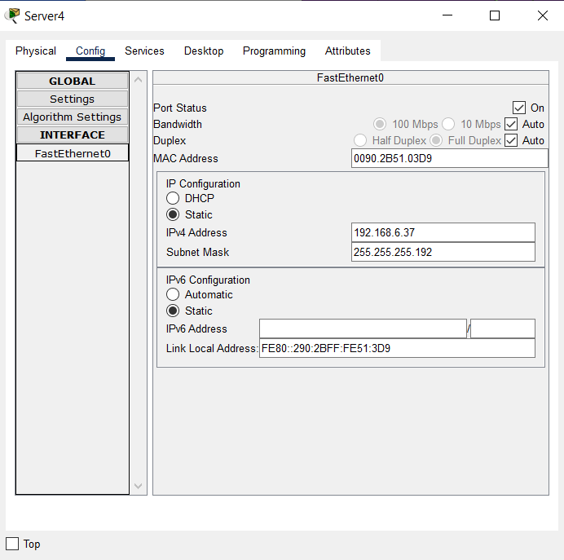

Laptop

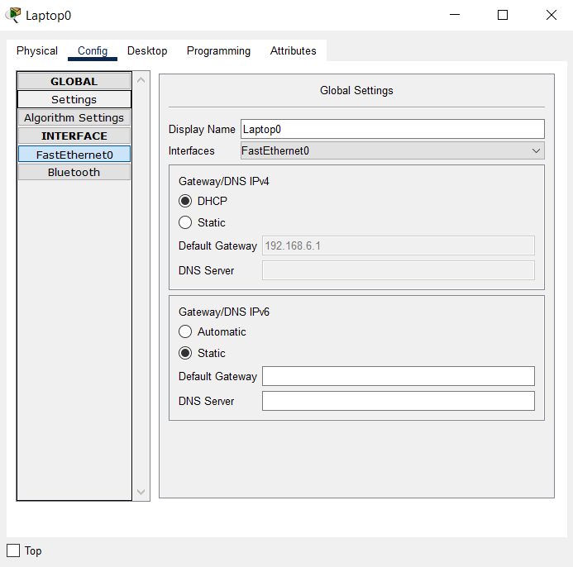

Laptop has ip address with the help of **DHCP.**

### Cyberjaya first floor (NPI000165-Pukar Nepali)

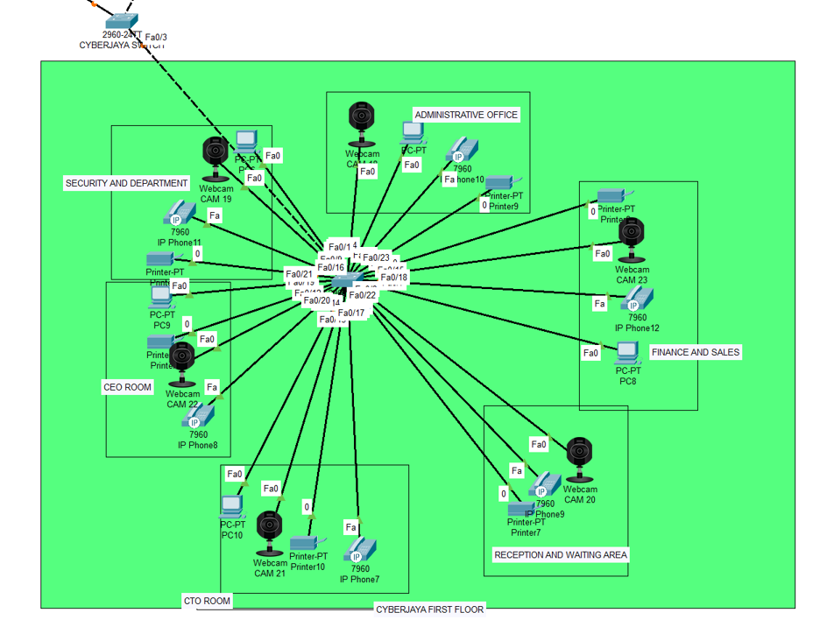

The figure above is designed in cisco packet tracer. This is the diagram representing the first floor of Cyberjaya building. There are six rooms per the question requirement. There are five computers, six printers, six CCTV cameras and six VoIP phones on two floors of Cyberjaya building. Each and every room is connected to the network with the help of some device. The host device from the first floor is connected to the switch using Ethernet cable with the help of copper. Furthermore, copper cross-over cable is use to connect switches. Star topology is used to design networks.

## Cyberjaya second floor (NPI000140-Ankit Acharya)

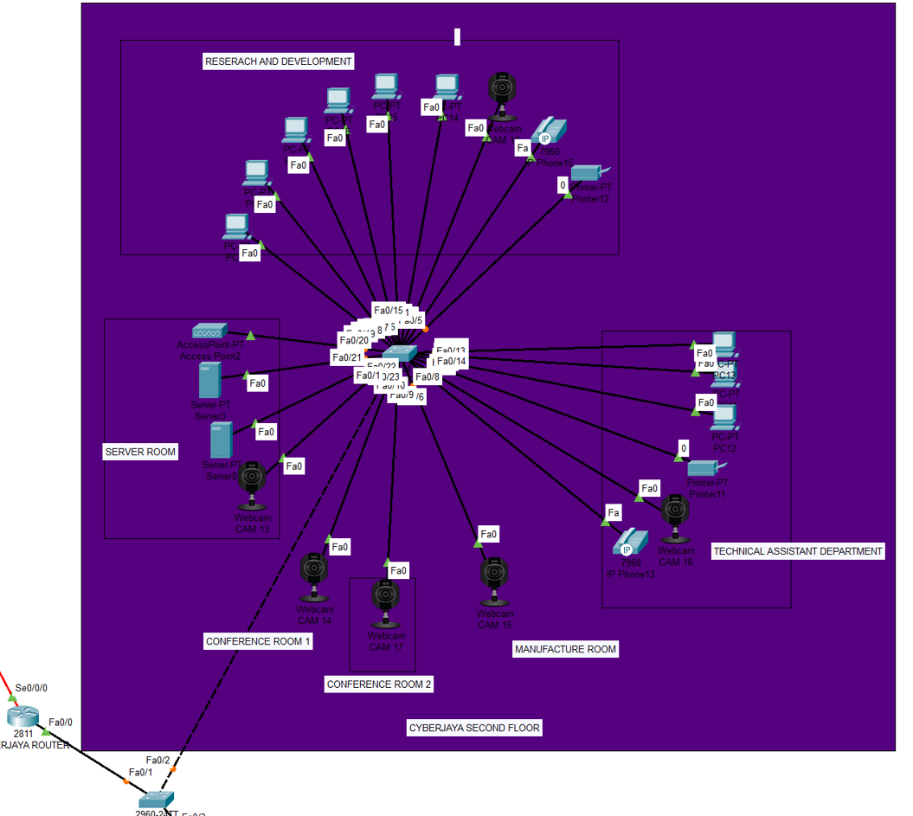

This is the networking figure of the Penang second floor where we can see that there are two server, one access point, nine computer, six CCTV camera, two VoIP and two printer. These device are also connected with the switch of that floor with the help of Ethernet cable and that switch also connected with the building switch with the help of cross over wire and then with the network. This floor is also design in star topology. In this floor also some device has Ip address i.e. dynamically taken and some have Ip address i.e., statically taken.

## Configuration involve in this building is done by (Pukar Nepali-NPI000165 & Ankit Acharya-NPI000140)

#### Configuration of switch of Penang building

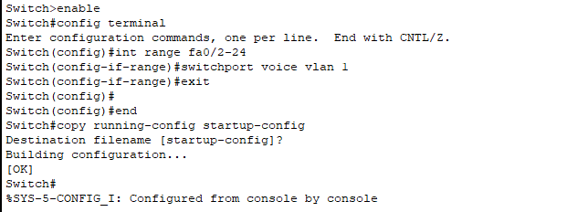

#### Router configuration of Cyberjaya building

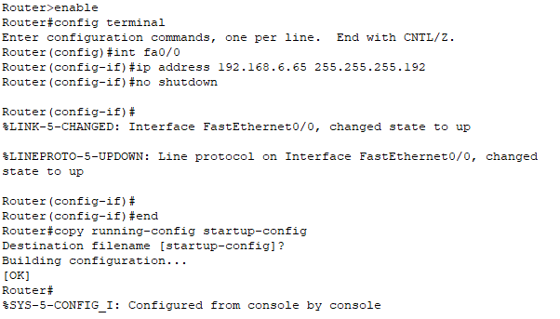

#### Configure DHCP pool to router of Cyberjaya building

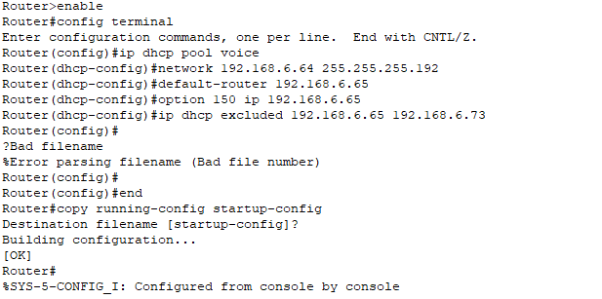

**With the help of DHCP PC has taken ip address automatically.**

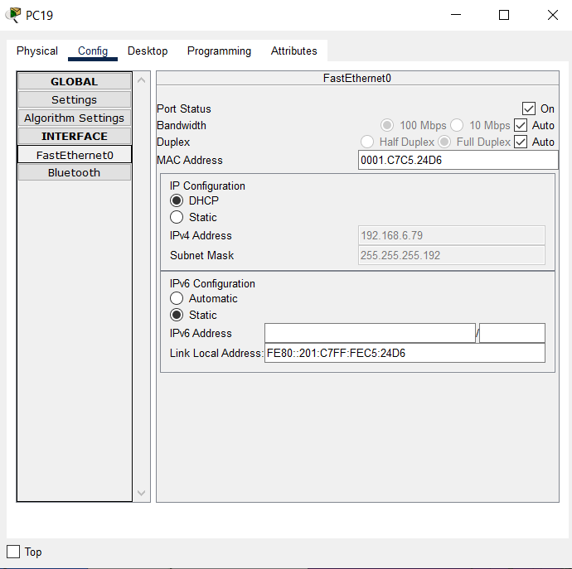

#### Telephony service configure of Penang building

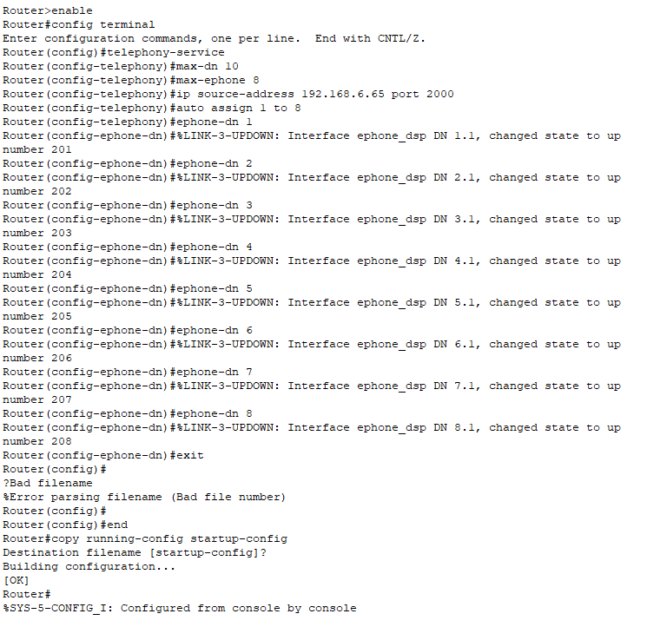

After configuration we connect the adapter in the VoIP phone.

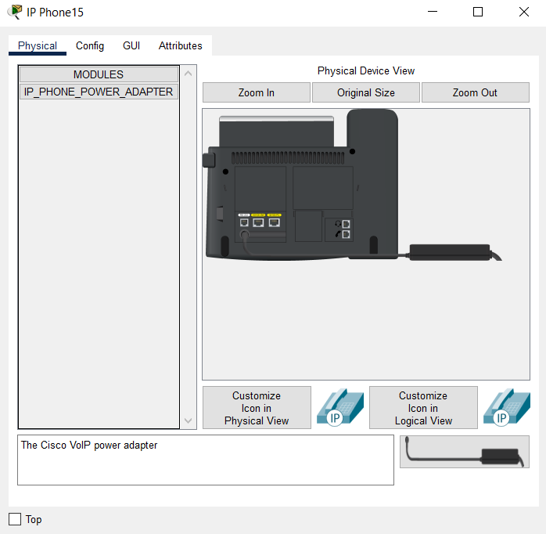

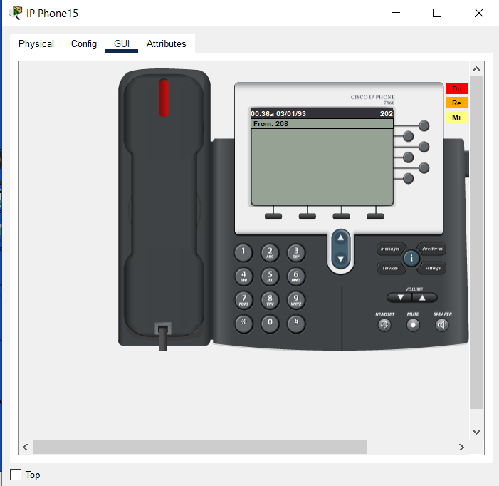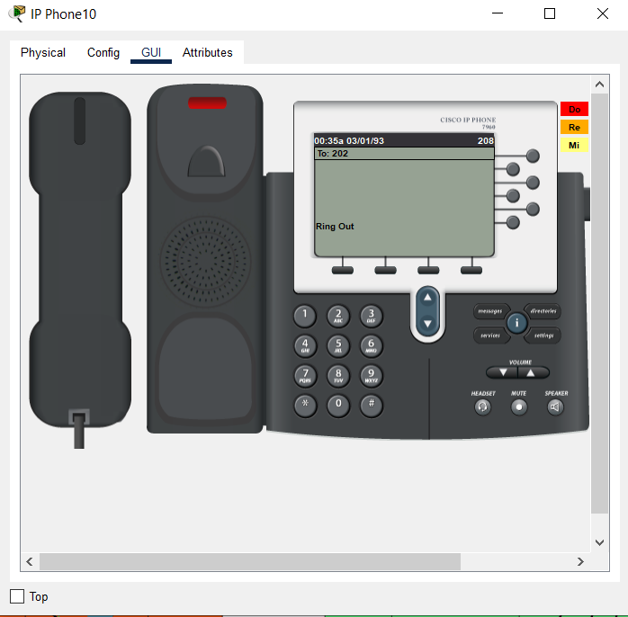

From the above figure you can see that we successfully connected the VoIP phone.

Furthermore, the printer, server and camera from the Penang building has given ip address statically.

**Server**

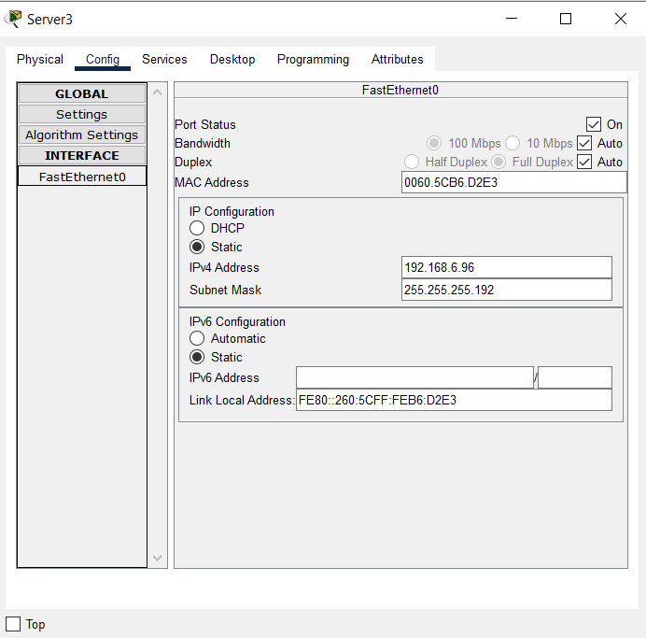

**CCTV**

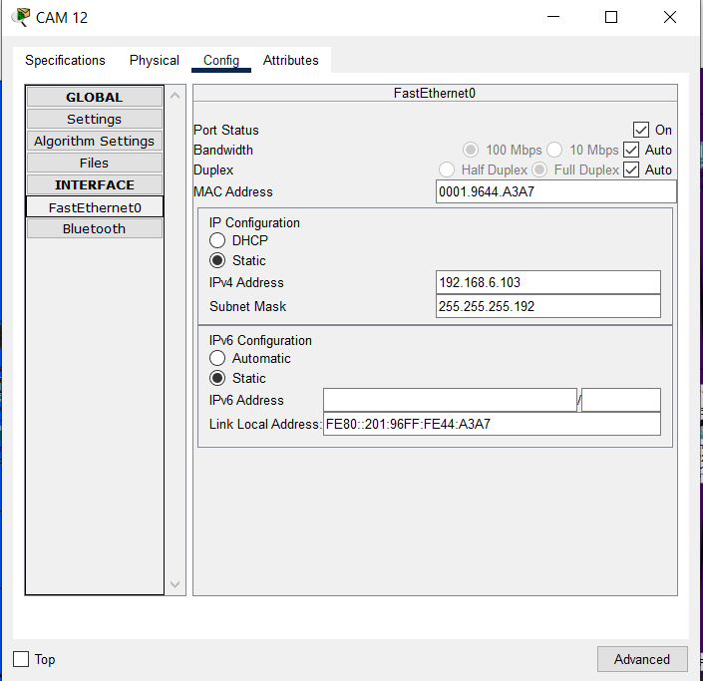

**Printer  
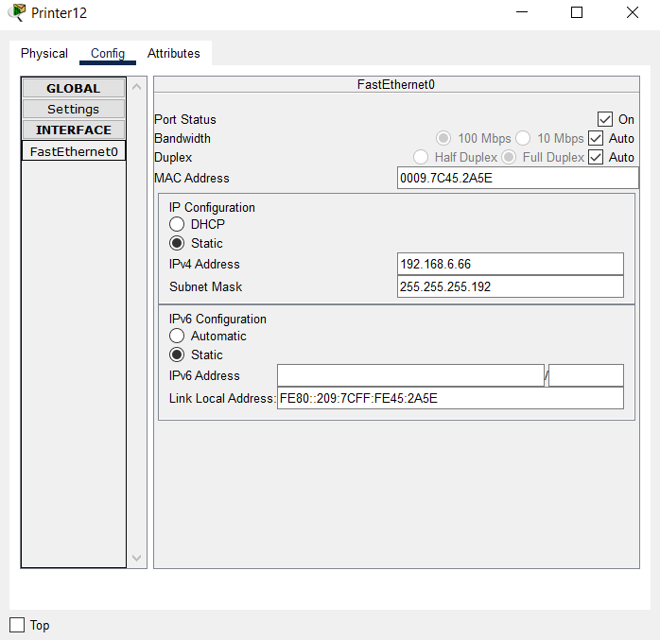**

## SERIAL LINK BETWEEN PENANG ROUTER AND CYBERJAYA ROUTER

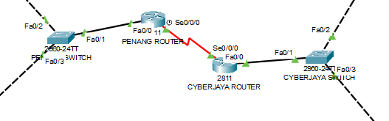

## Penang router serial link configuration

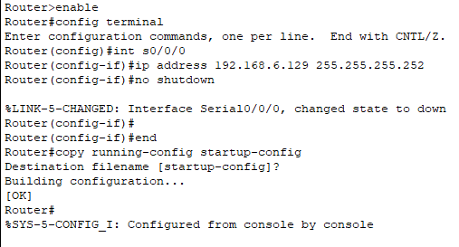

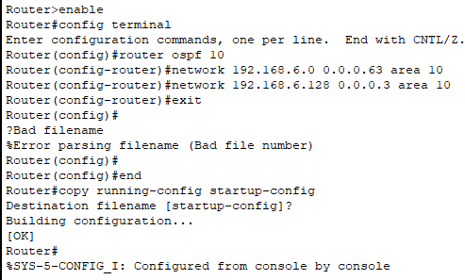

## Cyberjaya router serial link configuration

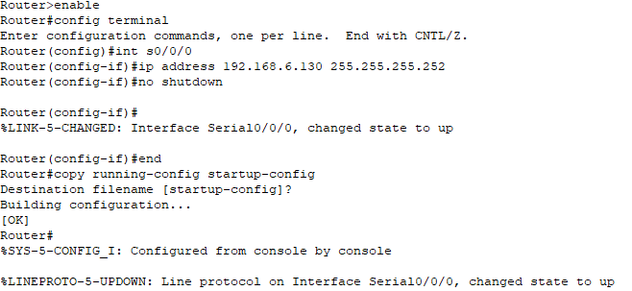

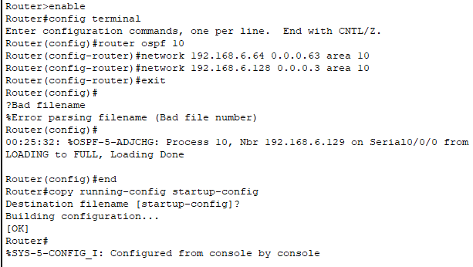

Confirming the connection of network between the devices of company by pinging each other.

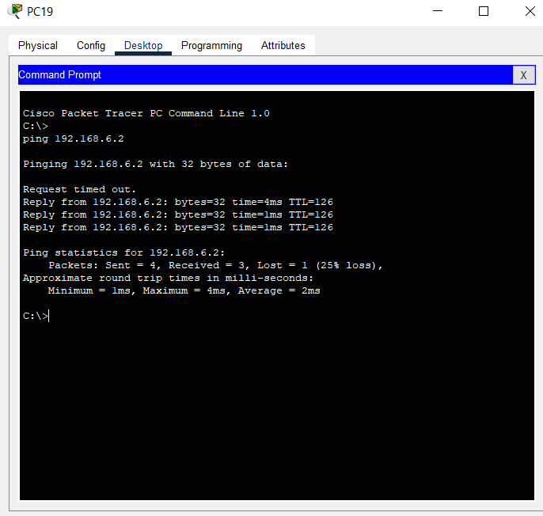

In the above figure we can see that the pc having ip address 192.168.6.79 which lie in second floor of the building of Cyberjaya has connected with the printer having ip address 192.168.6.2 which lie in second floor of building Penang.

## Penang building Dial peer configuration

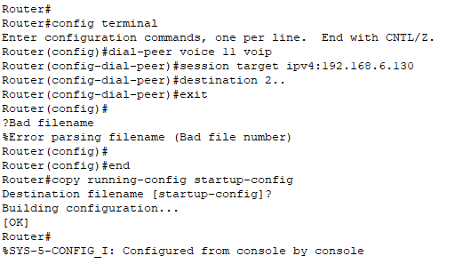

## Cyberjaya building Dial peer configuration

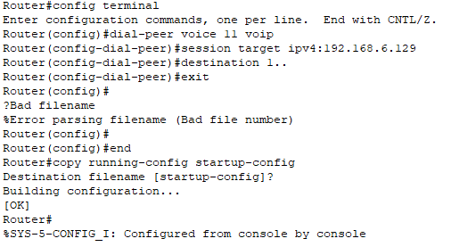

From the above dial peer configuration, it connect the two Ip phone form one building to another building.

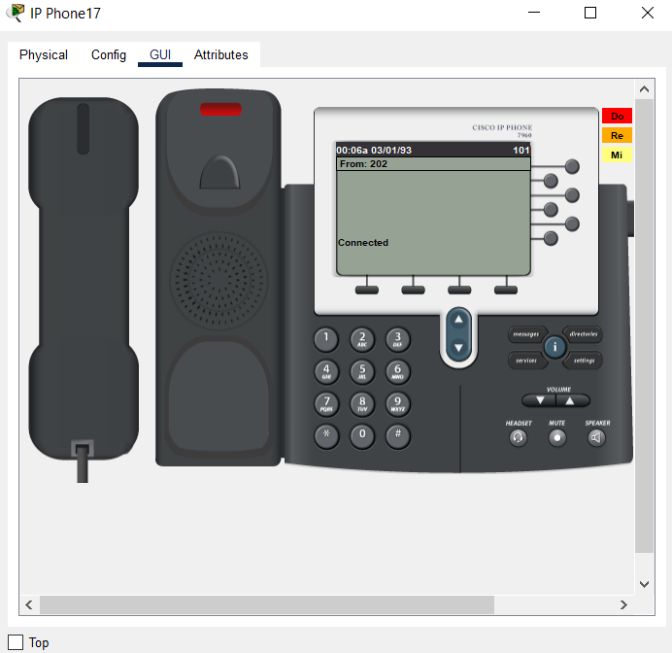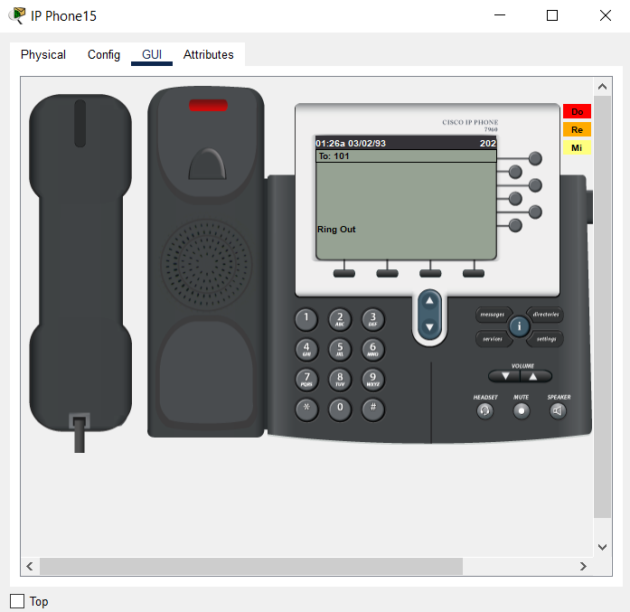

From the above figure, the connection between the VoIP from Cyberjaya is connected with the VoIP phone in Penang was successfully done.

## TOPOLOGY

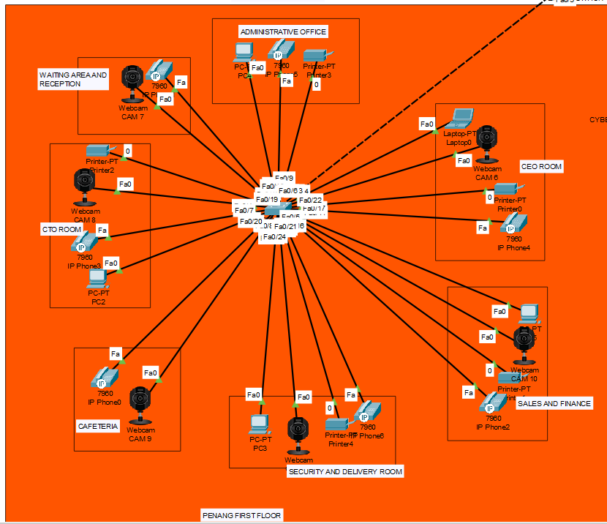

In this project we have used the popular topology use in networking i.e., star topology in both building Penang and Cyberjaya. In this topology, network is divided into multiple layer. In LAN, network device have three prime categories. In the bottom, layer computer is connected know as access layer. In middle layer, there are two layer where server are connected. From this topology, the new device which is use in company can be easily be connected and disconnected. Increasing speed of the internet is also easily done in this topology. It has some many advantage. So, in this project we have use this topology. Whereas, if there is network issue we can simply find the problem and overcome it. Maintenance- of the network will be easy.

## IP-Addressing

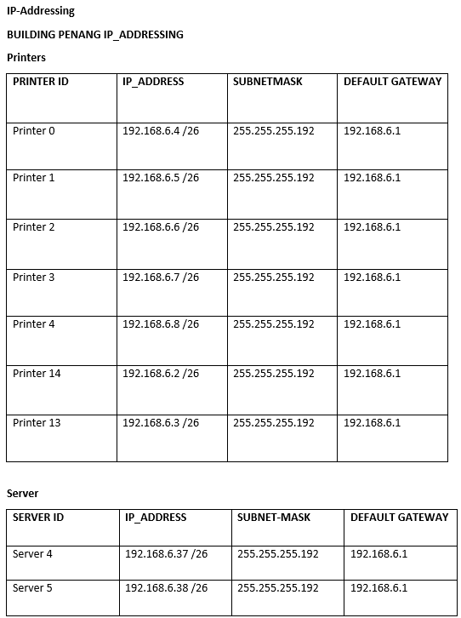

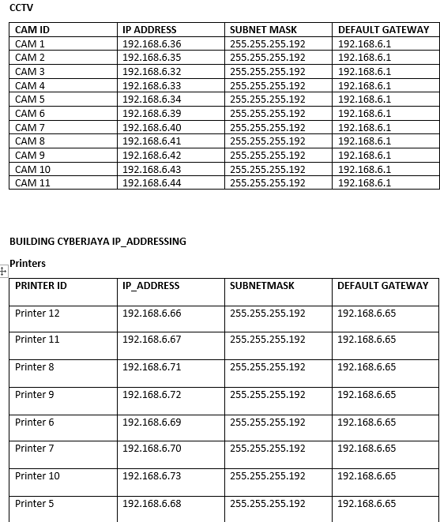

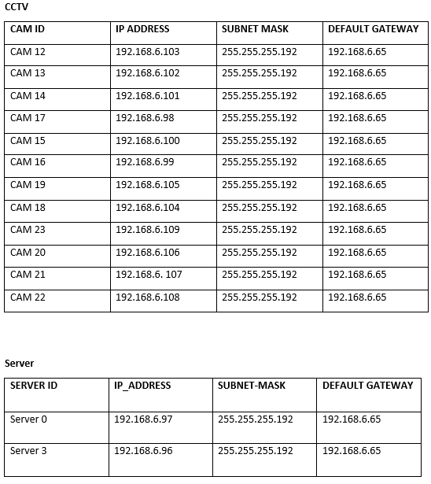

1. IP-ADDRESSING ROUTERS

**Penang**

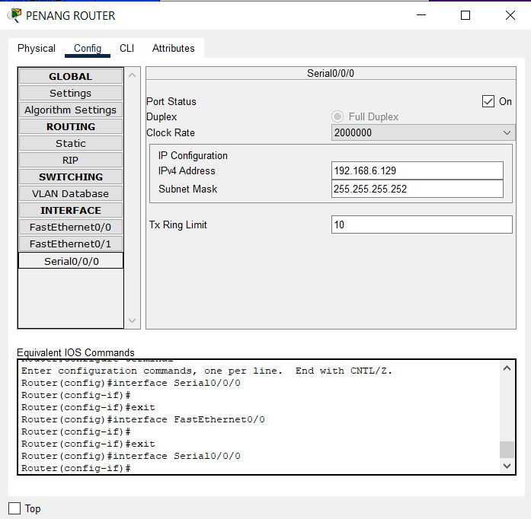

Serial 0/0/0

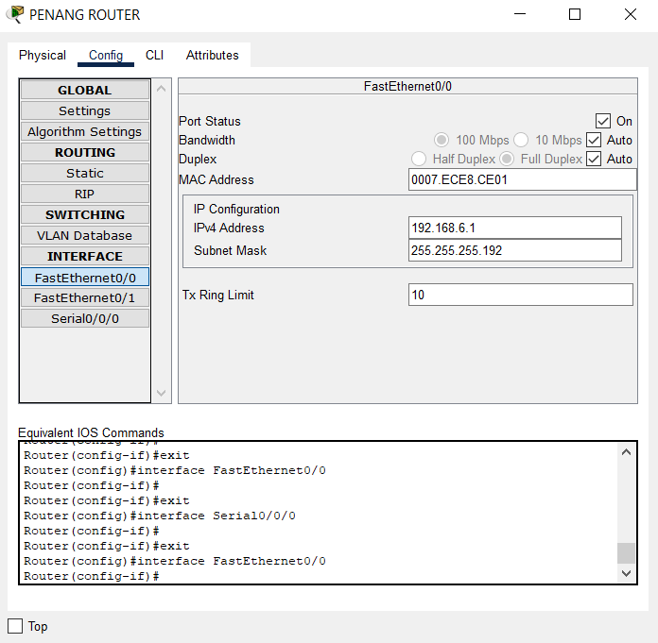

Fast 0/0

**Cyberjaya**

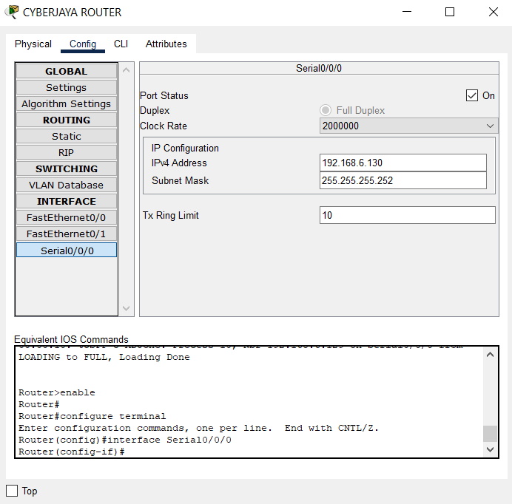

Serial 0/0/0

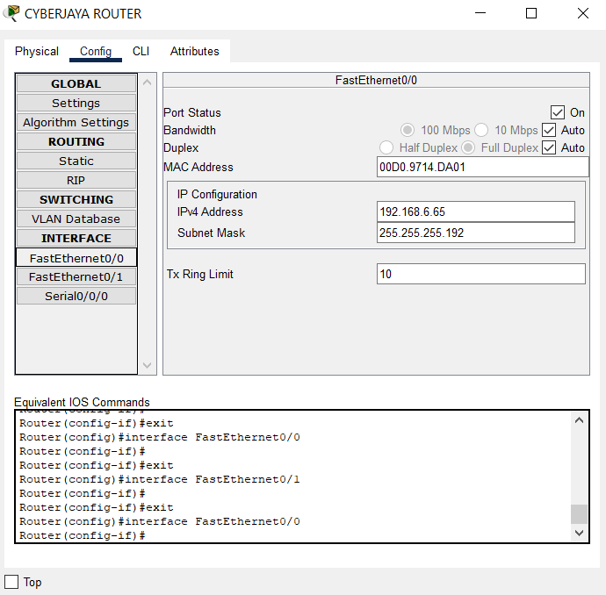

Fast 0/0

The Switch in 1st floor and Switch 2nd floor are connected to the Router-Penang through main Switch-Penang. Switch 1st floor and Switch in 2nd floor both uses 192.168.6.1 as default gateway whereas Switch Penang uses the default gateway of 192.168.6.1 Switch in 1st floor is located at CTO Room, Switch in 2nd floor is located at Server Room and Switch Penang is located at Stairs between two floors.

The Switch in 1st floor and Switch 2nd floor are connected to Router-Cyberjaya through Switch-Cyberjaya. Switch 1st floor and Switch in 2nd floor uses 192.168.6.65. as default gateway whereas Switch-Cyberjaya uses the default gateway of 192.168.6.65 Switch in 1st floor is located at CTO Room, Switch in 2nd floor is located at Server Room and Switch-Cyberjaya is located at Stair between two floors.

## Conclusion

This project was completed with the hard work and research of the whole team. The network design with network diagrams as well as network configuration was successfully done with the help of Cisco Packet Tracer. The floor design was done with the help of Microsoft Visio software. Overall, the requirement of Seagate Co. was successfully fulfilled.

WORKLOAD

|  |  |  |  |  |
| --- | --- | --- | --- | --- |
| ASSIGNMENT  TOPICS | ANKIT ACHARYA | JITEN CHAPAGAIN | SATINDRA BAHADUR  KHADKA | PUKAR NEPALI |
| Floor plan | 25 | 25 | 25 | 25 |
| Host and networking devices | 25 | 25 | 25 | 25 |
| Final configuration | 30 | 30 | 20 | 20 |
| Configuration | 20 | 20 | 30 | 30 |
| Topology | 25 | 25 | 25 | 25 |
| Subnetting | 25 | 25 | 25 | 25 |
| Ip-addressing | 25 | 25 | 25 | 25 |
| Signature | Ankit | Jiten | Satindra | Pukar |

## Reference

Sikkim Manipal University, Spring 2009,*Computer Networks*.

Network Fundamentals https://www.youtube.com/c/NetworkDirection

https://networkdirection.net/

Stallings, W. (1994), *Data and Computer Communications*, Fourth Edition,

Stallings, W. (1993), *Local and Metropolitan Area Networks*, Fourth Edition,   
Macmillan, NY. 

Stallings, W. (1993b) *Networking Standards*: A Guide to OSI, ISDN, LAN, and   
MAN Standards, Addison-Wesley, Reading, MA. 

 Stamper, D. (1993), *Local Area Networks*, Addison-Wesley, Reading, MA. 

Tanenbaum, A. (1989), *Computer Networks*, Second Edition, Prentice Hall,   
Englewood Cliffs, NJ. 

 Van Duuren, J., Schoute, F., and Kastelein, P. (1992) *Telecommunications*   
*Networks and Services,* Addison-Wesley, Reading, MA.

 Viniotis Y. and Onvural R. (editors) (1993) *Asynchronous Transfer Mode*   
*Networks,* Plenum, New York, NY. 

White, G. (1992) *Internetworking and Addressing*, McGraw-Hill, NY. 

Zitsen, W. (1990) ‘*Metropolitan Area Networks: Taking LANs into the Public*   
*Network,’ Telecommunications*.